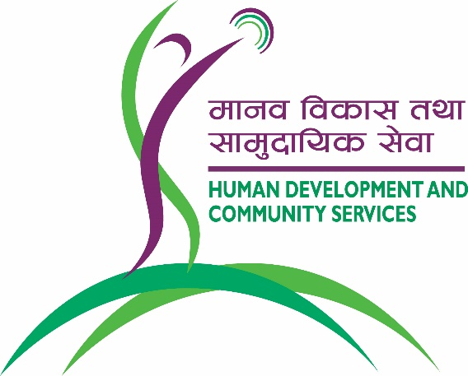**Livelihood Entrepreneurship Technician 3SR Project**

**Apply here**

[**https://rb.gy/nmoly**](https://rb.gy/nmoly)



|  |  |
| --- | --- |
| **Project Location :** | Chaurjahari, Rukum West, Nepal |
| **Service type :** | *Samriddha ra Surakshit Samudaya Rukum* (3SR) Project |
| **Type of Contract :** | Yearly contract for three years |
| **Post Level :** | Mid-level management |
| **Reports to:** | Project Coordinator |
| **Supervisory role:** | 5-8 people |
|  |  |

**Organisation Background:**

Human Development and Community Services (HDCS) is a faith-based NGO working in three main sectors of health, education, and community development since 1991. Currently, it manages various projects across Nepal especially in rural areas and provides services through hospitals, health camps, public health programs, disaster preparedness and response, school development programs, teacher training, educational daycare centres for children with special needs and community radio stations. The organisation is implementing *Samriddha ra Surakshit Samudaya Rukum (*3SR).

HDCS is committed to attract and retain the best employees from all ethnicities, gender and backgrounds in its vision to transform the communities by creating sustainable livelihood income.

**About project:**

HDCS is working closely with farmers, small and medium level entrepreneurs by creating integrated new concept of One Health approach and now linking with this a new project is being developed which is called ***S****amriddha ra* ***S****urakshit* ***S****amudaya-****R****ukum (3SR).* HDCS is willing to expand its collaborative effort with local stakeholders to scale up the initiative linking with various other projects so that 3SR is able to support farmer groups to systematize regular saving, establish small business, create local job and start up market promotion of local product. By doing this, HDCS would be able to establish and promote value chain linking with entrepreneurship in livelihood.

**Responsibilities:**

Livelihood Entrepreneurship Technician (LET) will be primarily responsible for giving technical input in all activities to ensure farmer groups, small and medium business entities are benefited, government units are able to contribute to establish livelihood value chain, cooperatives are well functional and able to serve effectively and team is able to apply market linkage effectively. To ensure they are trained, developed and are able to implement as well as track technical branding vending part of the product linking with government policies in respective area. It is a challenging role as it demands to demonstrate tangible result by setting up benchmark of local product marketing, setting up system and create extended partnership of BFIs in the community.

**Deliverables:**

* Provide leadership to impart cooperative management skill to the field staff
* Groups are registered and functional status is demonstrated by income
* Carry out survey/research for market analysis and further planning
* Local brand is identified, developed and promoted in market
* Develop and plan for training events and materials for market promotion
* Provide training to selected cooperatives, farmers, students, health workers, teachers, mother groups as per need
* Identify potential community groups and bring up them in value chain
* Equipment and technical advice is provided to model enterprises
* Conduct community stakeholder meetings to motivate for income generation
* Establish effective value chain of cooperative, market, BF institutions

**Requirements:**

* At least a bachelor’s degree or above with specialization in the fields of Cooperative management, Agro-based product promotion, Consumer market development, Project Management or other relevant field.
* Minimum 3 years of relevant work experience.
* Equipped with market promotional skill with dynamic team player capacity.
* Self-motivated and comfortable working in rural situation.
* Strong analytical problem-solving ability and creativity to bring new systems to the product.
* Experience in business promotion, Livelihood, Cooperative management, agro-based marketing etc.
* Learning attitude and willingness to develop technical expertise.
* Strong verbal and written communication skills in English and Nepal.